Digital System Design Lab
Virtual Lab – 1
Aim: To design and implement a 2 bit Comparator using logic gates in Verilog.
Software Required: ModelSim
Procedure:
- Open ModelSim, Create new project, new file and type the name.
- Select Verilog in that drop-down menu.
- Type the code, compile it.
- Type the test bench for it and compile and simulate it.
- Click Add Wave and Create the waveform.
- Repeat this steps for different modelling.
Truth Table:
The truth table is given below.
Inputs |  |  |  | X | Y | Z
A1(MSB) | A0 | B1(MSB) | B0 | A<B | A>B | A=B
0 | 0 | 0 | 0 | 0 | 0 | 1
0 | 0 | 0 | 1 | 1 | 0 | 0
0 | 0 | 1 | 0 | 1 | 0 | 0
0 | 0 | 1 | 1 | 1 | 0 | 0
0 | 1 | 0 | 0 | 0 | 1 | 0
0 | 1 | 0 | 1 | 0 | 0 | 1
0 | 1 | 1 | 0 | 1 | 0 | 0
0 | 1 | 1 | 1 | 1 | 0 | 0
1 | 0 | 0 | 0 | 0 | 1 | 0
1 | 0 | 0 | 1 | 0 | 1 | 0
1 | 0 | 1 | 0 | 0 | 0 | 1
1 | 0 | 1 | 1 | 1 | 0 | 0
1 | 1 | 0 | 0 | 0 | 1 | 0
1 | 1 | 0 | 1 | 0 | 1 | 0
1 | 1 | 1 | 0 | 0 | 1 | 0
1 | 1 | 1 | 1 | 0 | 0 | 1
Two 2 bit numbers A1,A0 and B1,B0 are compared with each other. X, Y and Z are outputs.
X=1 when A<B and 0 otherwise; Y=1 when A>B and 0 otherwise; and Z=1 when A=B and 0 otherwise.
K- Map:
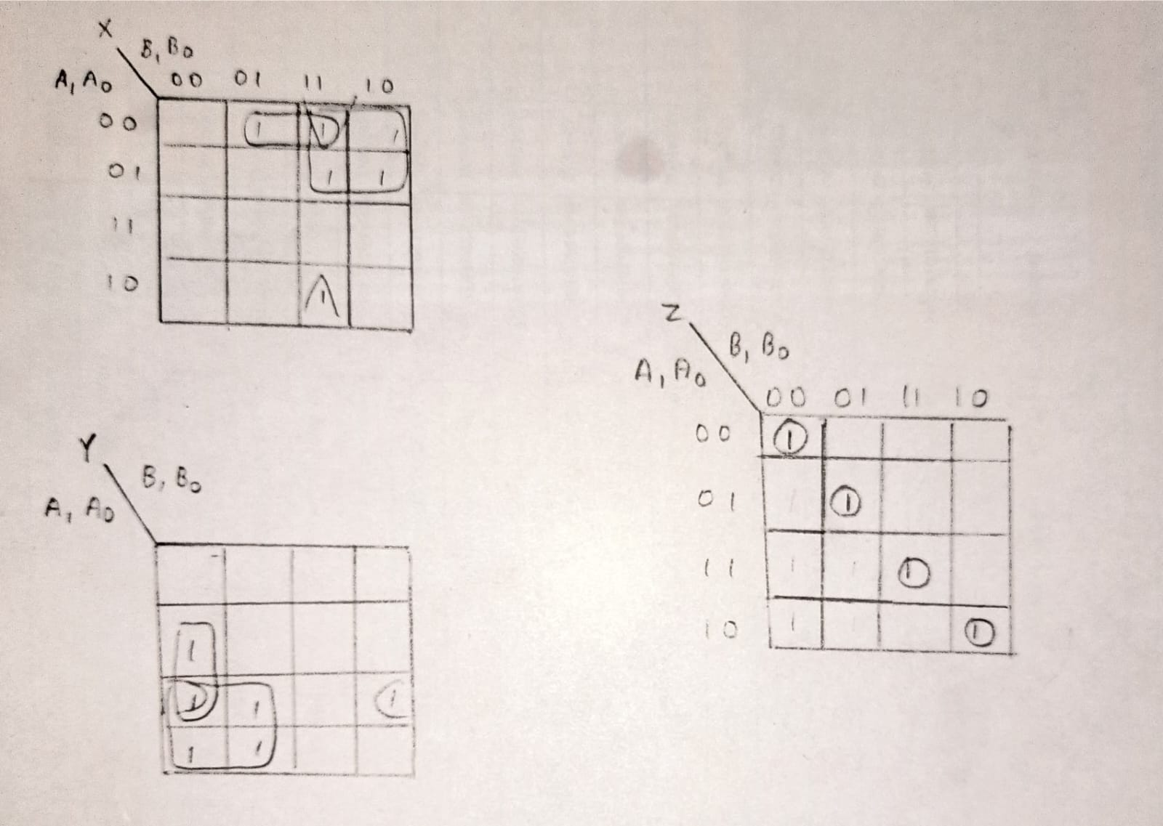
X = A1'A0'B0 + A0'B1B0 + A1'B1

Y = A0B1'B0' + A1A0B0' + A1B1'

Z = (A0 ⊙ B0)(A1 ⊙ B1)
Logic Diagram:
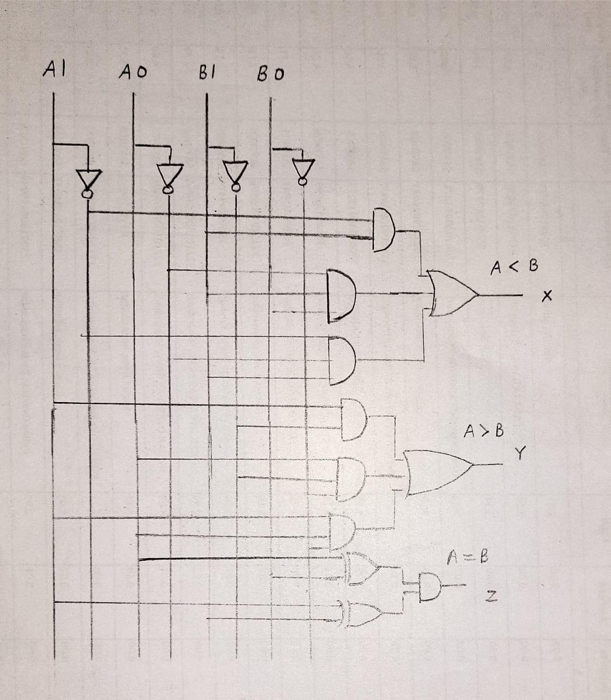
Verilog Code:
Gate Modelling:
module vlgm (A1,A0,B1,B0,X,Y,Z);
input A1,A0,B1,B0;
output X,Y,Z;
wire i1,i2,i3,i4,i5,i6,i7,i8,i9,i10,i11,i12;
not a1 (i1,A0);
not a2 (i2,A1);
not a3 (i3,B0);
not a4 (i4,B1);
and a5 (i5,i1,i2,B0);
and a6 (i6,i1,B0,B1);
and a7 (i7,i2,B1);
or a8 (X,i5,i6,i7);
and a9 (i8,A0,A1,i3);
and a10 (i9,A0,i3,i4);
and a11 (i10,A1,i4);
or a12 (Y,i8,i9,i10);
xnor a13 (i11,A0,B0);
xnor a14 (i12,A1,B1);
and a15 (Z,i11,i12);
endmodule
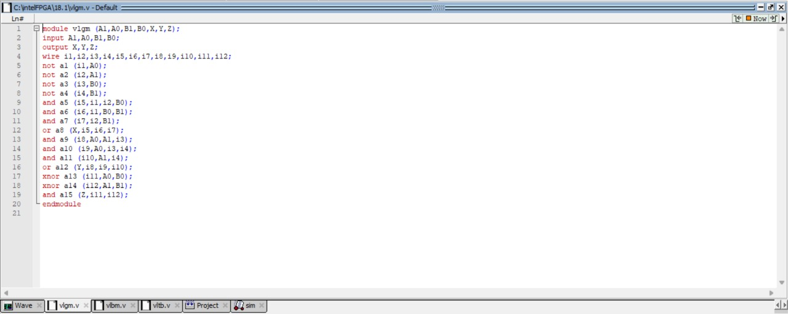
Data Flow Modelling:
module vldfm (A1,A0,B1,B0,X,Y,Z);
input A1,A0,B1,B0;
output X,Y,Z;
assign X = (~A0&~A1&B0)|(~A0&B0&B1)|(~A1&B1);
assign Y = (A0&A1&~B0)|(A0&~B0&~B1)|(A1&~B1);
assign Z = (A0~^B0)&(A1~^B1);
endmodule
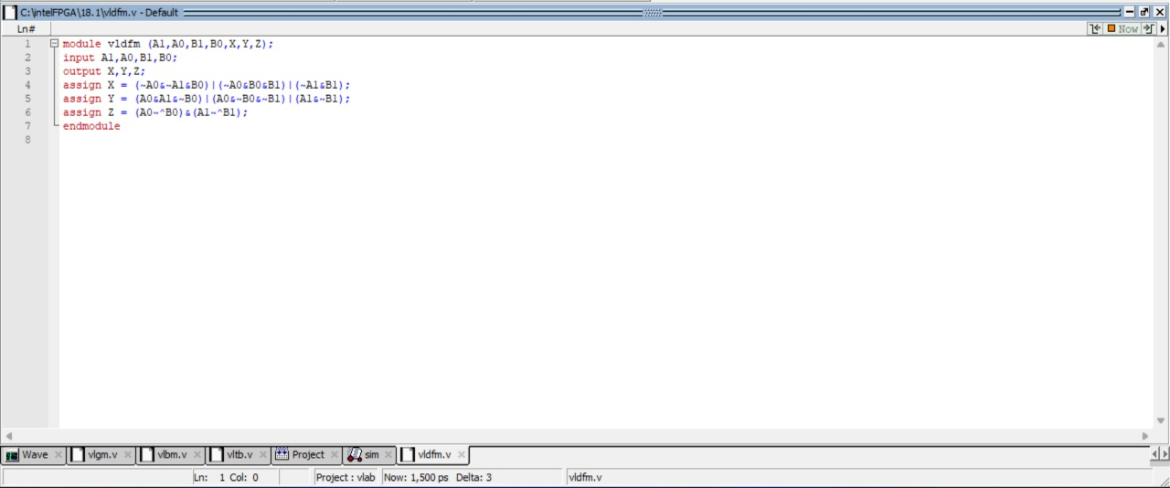
Behavioural Modelling:
module vlbm (A1,A0,B1,B0,X,Y,Z);
input A1,A0,B1,B0;
output reg X,Y,Z;
always @ (A1,A0,B1,B0)
case ({A1,A0,B1,B0})
4'b0000: begin X = 0; Y = 0; Z = 1; end
4'b0001: begin X = 1; Y = 0; Z = 0; end
4'b0010: begin X = 1; Y = 0; Z = 0; end
4'b0011: begin X = 1; Y = 0; Z = 0; end
4'b0100: begin X = 0; Y = 1; Z = 0; end
4'b0101: begin X = 0; Y = 0; Z = 1; end
4'b0110: begin X = 1; Y = 0; Z = 0; end
4'b0111: begin X = 1; Y = 0; Z = 0; end
4'b1000: begin X = 0; Y = 1; Z = 0; end
4'b1001: begin X = 0; Y = 1; Z = 0; end
4'b1010: begin X = 0; Y = 0; Z = 1; end
4'b1011: begin X = 1; Y = 0; Z = 0; end
4'b1100: begin X = 0; Y = 1; Z = 0; end
4'b1101: begin X = 0; Y = 1; Z = 0; end
4'b1110: begin X = 0; Y = 1; Z = 0; end
4'b1111: begin X = 0; Y = 0; Z = 1; end
endcase
endmodule
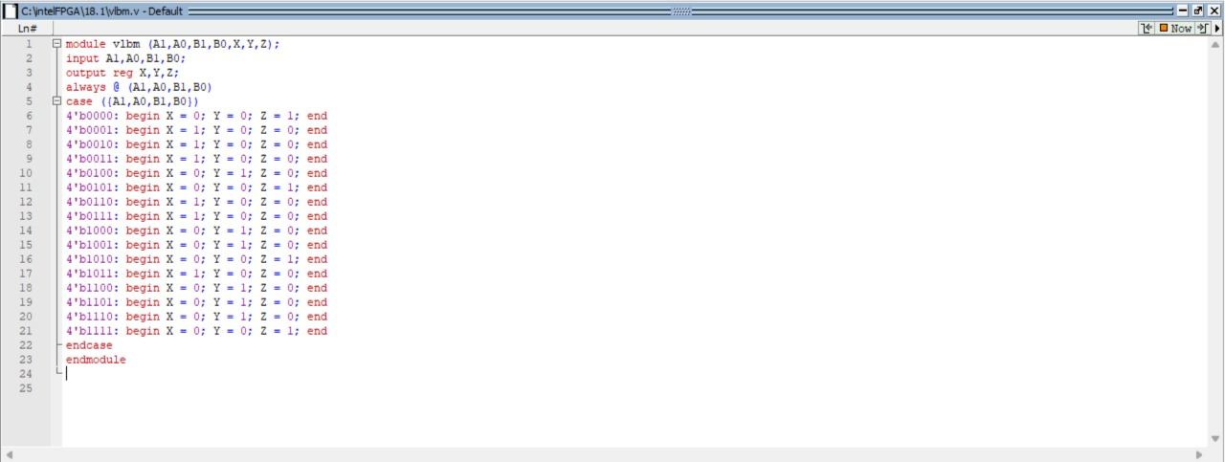
Test Bench:
module vltb;
reg A1,A0,B1,B0;
wire X,Y,Z;
vlgm dut (.A1(A1),.A0(A0),.B1(B1),.B0(B0),.X(X),.Y(Y),.Z(Z));
initial begin
$monitor (A1,A0,B1,B0,X,Y,Z);
A1 = 1'b0;
A0 = 1'b0;
B1 = 1'b0;
B0 = 1'b0;
#100
A1 = 1'b0;
A0 = 1'b0;
B1 = 1'b0;
B0 = 1'b1;
#100
A1 = 1'b0;
A0 = 1'b0;
B1 = 1'b1;
B0 = 1'b0;
#100
A1 = 1'b0;
A0 = 1'b0;
B1 = 1'b1;
B0 = 1'b1;
#100
A1 = 1'b0;
A0 = 1'b1;
B1 = 1'b0;
B0 = 1'b0;
#100
A1 = 1'b0;
A0 = 1'b1;
B1 = 1'b0;
B0 = 1'b1;
#100
A1 = 1'b0;
A0 = 1'b1;
B1 = 1'b1;
B0 = 1'b0;
#100
A1 = 1'b0;
A0 = 1'b1;
B1 = 1'b1;
B0 = 1'b1;
#100
A1 = 1'b1;
A0 = 1'b0;
B1 = 1'b0;
B0 = 1'b0;
#100
A1 = 1'b1;
A0 = 1'b0;
B1 = 1'b0;
B0 = 1'b1;
#100
A1 = 1'b1;
A0 = 1'b0;
B1 = 1'b1;
B0 = 1'b0;
#100
A1 = 1'b1;
A0 = 1'b0;
B1 = 1'b1;
B0 = 1'b1;
#100
A1 = 1'b1;
A0 = 1'b1;
B1 = 1'b0;
B0 = 1'b0;
#100
A1 = 1'b1;
A0 = 1'b1;
B1 = 1'b0;
B0 = 1'b1;
#100A
A1 = 1'b1;
A0 = 1'b1;
B1 = 1'b0;
B0 = 1'b1;
#100
A1 = 1'b1;
A0 = 1'b1;
B1 = 1'b1;
B0 = 1'b1;
end
endmodule
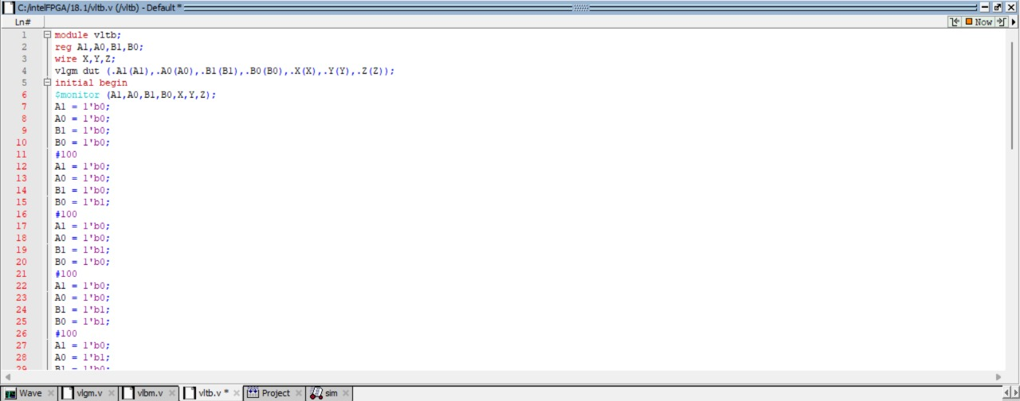
Output:
Gate Modelling:
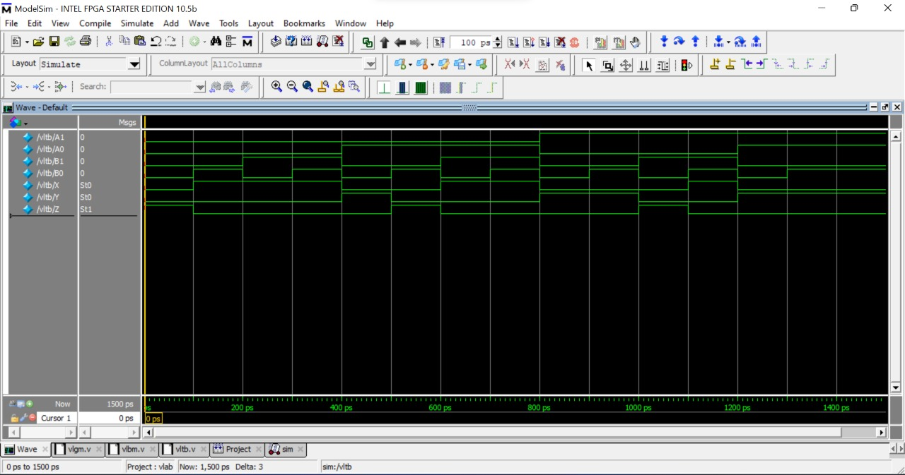
Data Flow Modelling:

Behavioural Modelling:

Result:
A 2 bit Comparator is designed and implemented using logic gates in Verilog.

